EXPLORATORY DATA ANALYSIS OF THE MELANOMA DATASET IN R
BENJAMIN BOGWAM PHILIP
7CS039/UM1: STATISTICS FOR DATA SCIENCE

1. INTRODUCTION
This report is an exploratory data analysis for the melanoma data set using R. The data set encompasses observations on melanoma patients, detailing various factors:

- Time since operation: Survival duration in days post-operation
- Status: Patient's status at study conclusion. (1) for melanoma-related death, (2) for survival, and (3) for non-melanoma-related death.
- Sex: (1) representing male and (0) representing female.
- Age: Patient's age in years during the operation.
- Year: Year of the operation.
- Thickness: Tumour thickness measured in mm.
- Ulcer: Presence (1) or absence (0) of ulceration.

The aim is to explore the relationship between tumour thickness, and post-operation status, assessing how this association varies across age, gender, and time since operation.

2. MELANOMA DATA SET SUMMARY

2.1. Numerical Summaries of the melanoma data set.
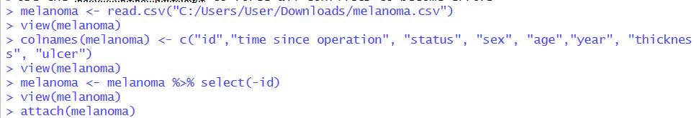

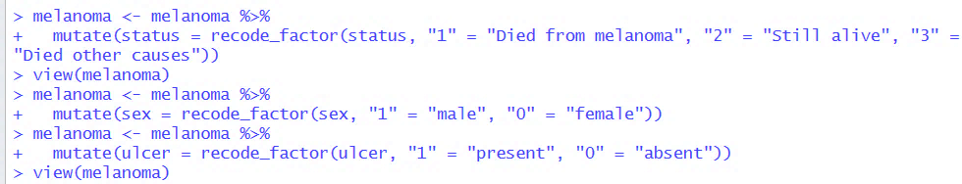
Figure 1. Showing R codes.
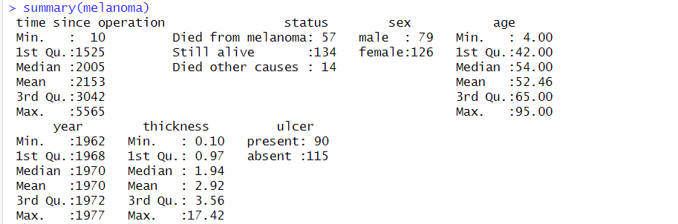

Figure 2. Showing the graphical summary of the melanoma data set
The first picture (Figure 1) shows some R code on how we've loaded the data in R reformat certain numbers representing "status," "sex," and "ulcer" in the melanoma data to make it easier to read and analyse. Then, in the second picture (Figure 2), we've put together some numerical summaries for the melanoma data set. These summaries explore different patients diagnosed with melanoma over a long period, with various ages, outcomes after surgery, and differences in tumour thickness.
Looking at the numerical summaries in Figure 2, we can see that the melanoma dataset covers cases from a wide range. This data could be explored further to gain more insights into the disease, how treatments worked, and possible connections between things like age, tumour thickness, and survival rates.
Taking a closer look at the numbers, the time patients survived after surgery varies a lot. The shortest survival time is 10 days, while the longest is approximately 15 years. This suggests that there's a big gap between surgeries and different follow-up periods. Also, most patients (134) are still alive, 57 sadly passed away because of melanoma, and 14 died from other causes not related to melanoma. Looking at gender, there are more women (126) than men (79) in the dataset. Ages range from 4 to 95, with the average age being 52.46. Most patients are between 42 and 65 years old. Surgeries happened between 1962 and 1977, with the majority occurring in the late 1960s to early 1970s. The thickness of melanomas varies a lot, with an average of 2.92 mm and sizes ranging from 0.10 mm to 17.42 mm. Lastly, there are fewer tumours that have ulcers (115) compared to those without ulcers (90).
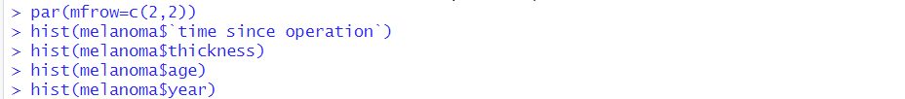
2. 2. Graphical Summaries of the Melanoma Data set.
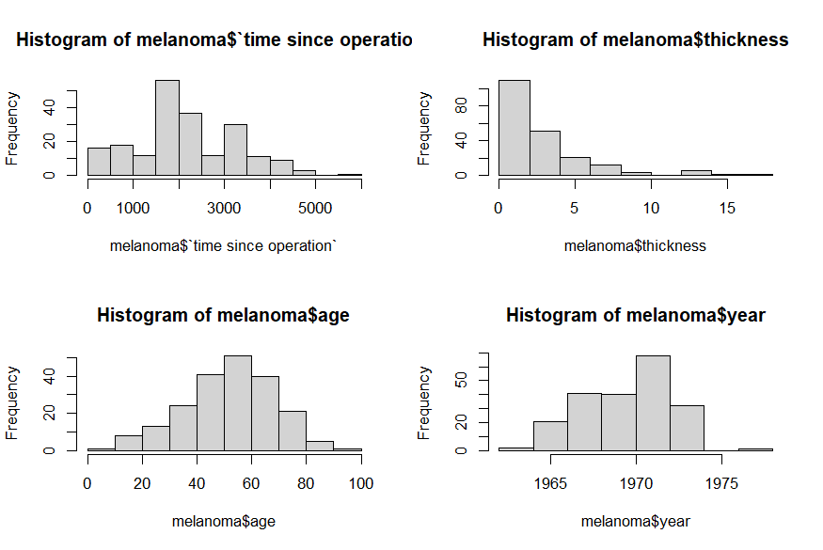

Figure 3. A histogram for time since operation, thickness, age, and year.
The charts in Figure 3 show how certain variables (survival time, tumour thickness, age, and year) are spread out in the melanoma data set.
Now, looking at the graph for "time since operation" in days, the overall shape is symmetrical with a clear peak around 2000 days. There's also a peak around 3000-4000 days. This suggests that most melanoma patients survived up to 2000 days, but there's another group that make it up to 3000-4000 days. For the "thickness" variable, which shows how thick the tumour is, it is skewed to the right, with a peak around 0-2 mm. The "age" variable, representing how old the patients are, is symmetrical and unimodal around 50 to 60 years.
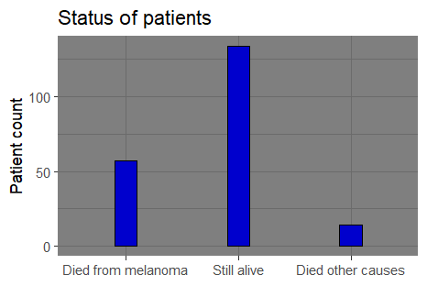
Now, checking out the graph for the "year" variable, it's skewed to the left, unimodal with peak around 1970 to 1973. This peak suggests that majority of melanoma surgeries happened around that time. There might be some outliers for thickness, time since operation, and year, and we will see if they affect our analysis to a greater extent.
Figure 4: Bar chart representing status of patients.

The bar chart in (Figure 4) displays the distribution for the variable “Status” shows more patients (134) were still alive than the summation of those who died either from melanoma (57) or from other causes unrelated to melanoma (14) at the end of the study.

3. REGRESSION ANALYSIS
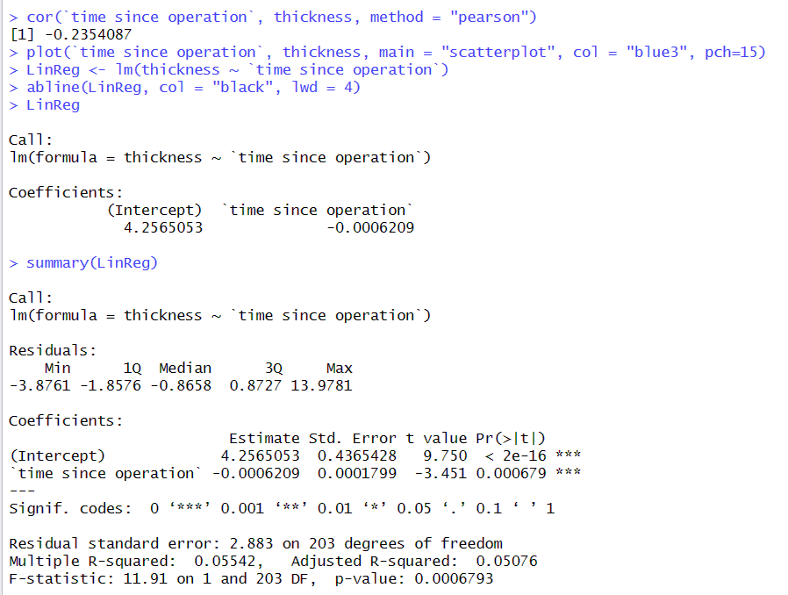
The R codes picture in (Figure 5) is the correlation computation and linear regression model for time ~ thickness for the melanoma dataset from R. The correlation coefficient = -0.23, this shows a weak negative linear relationship between survival time and tumour thickness.
Figure 5. time since operation ~ thickness (Correlation & Regression model)
Thereafter, for our regression analysis, we plot a scatterplot between the two variables, and built a linear regression model. The general line equation for our model is.
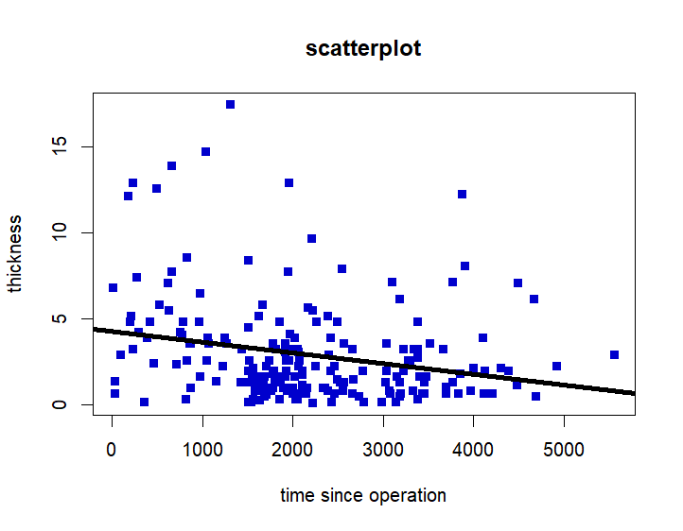
y = mx + c, where m is the slope (-0.0006209) and C the intercept (4.3) y = -0.00062x + 4.3 where y = thickness, x = time since operation thickness= 4.26 – 0.00062(time since operation)
Figure 6. Scatterplot showing the regression line of time since operation ~ thickness.

The R codes picture in (Figure 7) below is the correlation computation and linear regression model for time ~ age. The correlation coefficient = -0.30, this shows a weak negative linear relationship between survival time and patients’ age. Thereafter, we plot a scatterplot between the two variables, and built a linear regression model. The general line equation for our model is y = mx + c, where m is the slope (-0.0045) and C the intercept (62.1)
y = -0.0045x + 62.1
where y = age, x = time since operation
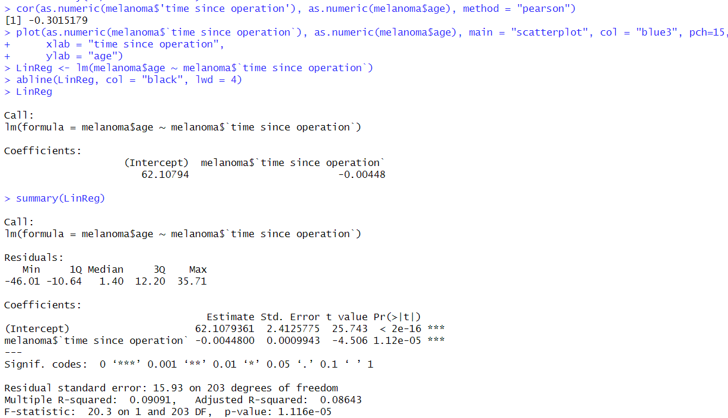
age = 62.11 – 0.0045(time since operation
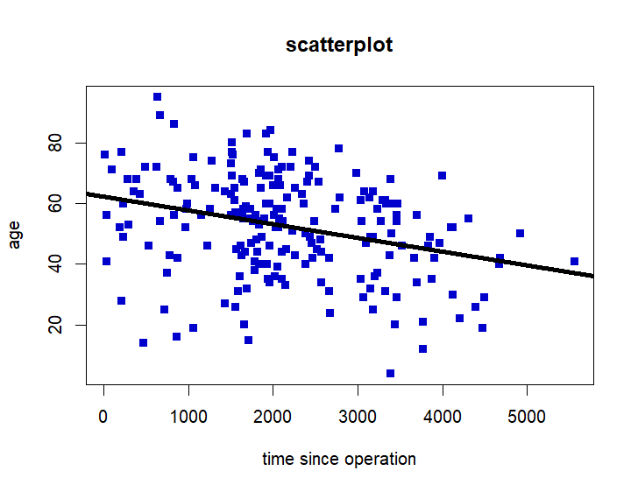
Figure 7. time since operation ~ age (Correlation & Regression model)
Figure 8. Scatterplot showing the regression line of time since operation ~ age.
The R codes screenshot (Figure 9) below compute the correlation and uses linear regression to explore the relationship between tumour thickness and age of patients from the melanoma dataset using R. The correlation coefficient = 0.21, this displays a weak positive linear relationship between tumour thickness and patients’ age. Then we plot a scatterplot between the two variables and built a linear regression model. The general line equation for our model is y = mx + c, where m is the slope (1.20) and C the intercept (49.0) y = 1.20x + 49.0
where y = age, x = thickness
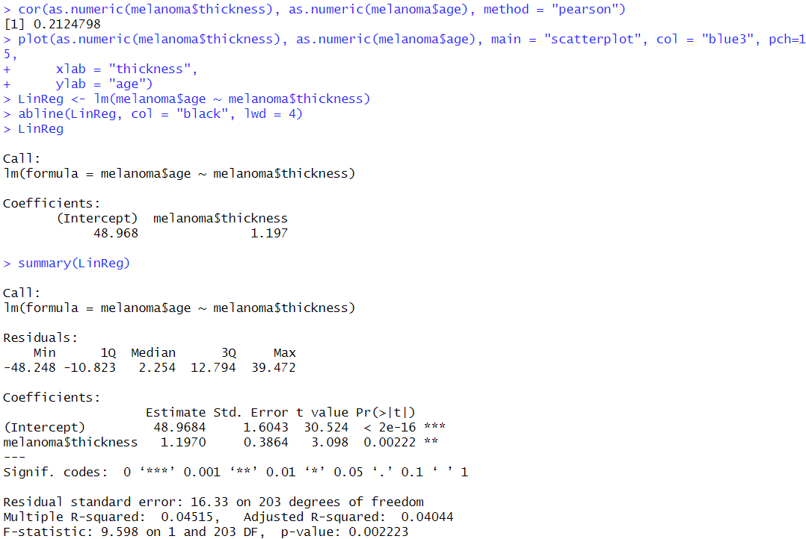
age = 48.97 + 1.2(thickness)
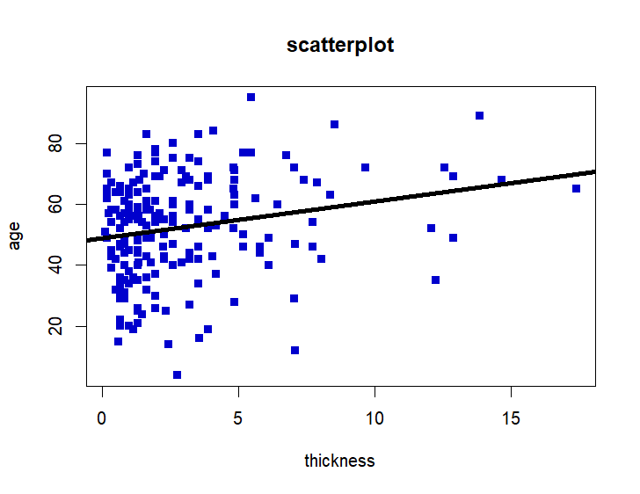
Figure 9. thickness~ age (Correlation & Regression model)
Figure 10. Scatterplot showing the regression line of thickness~ age.

4. COMMENTARY ON CORRELATION REGRESSION ANALYSIS
4.1 Commentary on `time since operation` ~ thickness relationship
In Figure 5, the negative correlation coefficient suggests that, on average, as survival time increases, tumour thickness tends to decrease, though this relationship isn't very strong. When the tumour thickness decreases by about 0.0006209, there's a corresponding increase in survival time. The model seems to fit quite well, and the link between survival time and tumour thickness is statistically significant with 95% confidence. This confidence comes from the p-value (0.0006793) associated with 'time since operation,' which is less than 0.05. However, the adjusted R-squared value is relatively low at 0.05076. This indicates that only a small portion (5%) of the variability in thickness has an impact on survival time. Other factors may also play a role in determining survival time.

4.2 Commentary on `time since operation` ~ age relationship
The analysis shows a statistically significant but weak negative linear relationship between survival time and age. In Figure 7 the intercept is approximately 62.10794. The coefficient for 'time since operation' is approximately -0.00448, indicating that for each unit increase in survival time, age decreases by approximately 0.00448 years. The negative correlation suggests that survival time increases among lower age groups patients. The model explains only a small portion of the variability in age, other factors not included in the model might contribute significantly to determining an individual's survival time in this context.

4.3 Commentary on thickness ~ age relationship
The correlation coefficient between thickness and age is approximately 0.212. This value suggests a weak positive linear relationship between these variables. A positive correlation of this magnitude implies that as 'thickness' increases, 'age' tends to increase slightly, for each unit increase in thickness, age increases by approximately 1.197 years. This implies then that thicker tumours are found within the higher age group patients, and though the relationship is statistically significant (p-value = 0.002223, 95% confidence interval) the relationship is not strong.

5. SIGNIFICANCE TEST
5.1 Two Sample t-test for Difference in Mean `time since operation` for Male and Female
- Null Hypothesis (Ho): The true difference in mean for survival time between males and females is equal to zero.
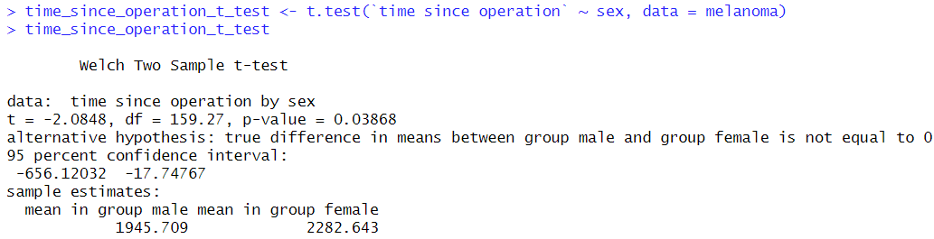
- Alternative Hypothesis (H1): The true difference in mean for survival time between males and females is not equal to zero.
Figure 11. Welch two Sample t-test.

In Figure 11 above, the p-value = 0.03868, this is less than the typical significance level of 0.05, there is evidence to reject the null hypothesis. There is a statistically significant difference in the mean survival time between males and females in the melanoma dataset.
The 95% confidence interval for the difference in means is between -656.12032 and -17.74767, favouring females having a longer mean survival time compared to males. So, based on this test, we reject the null hypothesis.
5.2. Two Sample t-test for Difference in Mean Age between Male and Female
- Null Hypothesis (Ho): There is no significant difference in the mean ages between males and females.
- Alternative Hypothesis (H1): There is a significant difference in the mean ages between males and females.
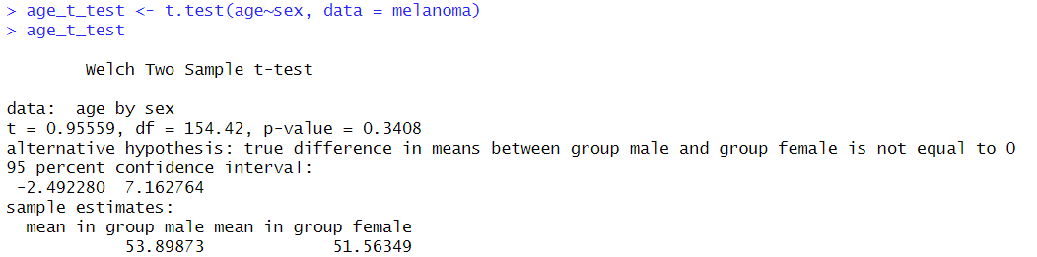
Figure 12. Welch Two Sample t-test.

Based on the 95% confidence interval for the difference in means (-2.492280, 7.162764) from Figure 12 and (p-value = 0.3408) which is greater than the common significance level of (0.05) indicating that there isn't sufficient evidence to reject the null hypothesis, we do not see a statistically significant differences in the mean ages between male and female with melanoma in the dataset. Therefore, we do not reject the null hypothesis.

5.3. Two Sample t-test for Difference in Mean Thickness between Male and Female
- Null Hypothesis (Ho): There is no significant difference in the mean thickness between males and females in the melanoma dataset.
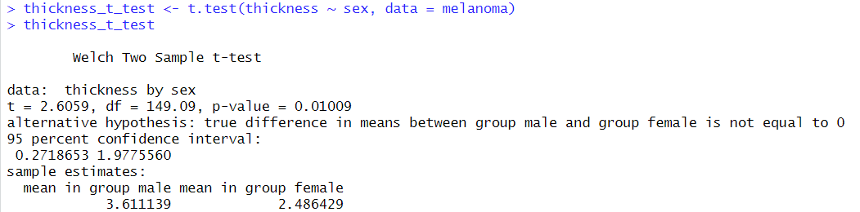
- Alternative Hypothesis (H1): There is a significant difference in the mean thickness between males and females.
Figure 13. Welch Two Sample t-test.
The statistical analysis indicates that there is a statistically significant difference in the mean thickness between male and female groups with melanoma. The confidence interval (0.2718653, 1.9775560) suggests that, on average, the thickness of melanoma for males tends to be higher compared to females. The (p-value = 0.01009) figure 13 is less than the common significance level of (0.05) There is sufficient evidence to reject the null hypothesis, therefore we reject the null hypothesis.

6. TEST FOR NORMALITY FOR SOME VARIABLES IN THE MELANOMA DATA SET (QQ-PLOT)
6.1 QQ-plots for time since operation grouped by gender.
Figure 14. Showing QQ-plot R code screenshot for time since operation grouped by sex.
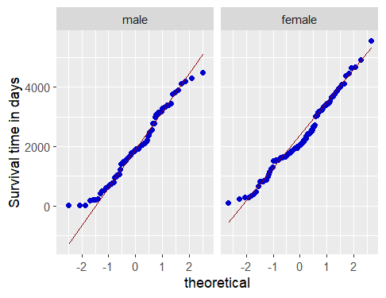
Figure 15. Showing a QQ-plot for survival time grouped by sex.
The qq-plot for survival time is approximately normal for both genders.
6.2 QQ-plots for age grouped by gender.

Figure 16. Showing QQ-plot R code screenshot for patients’ age grouped by sex.
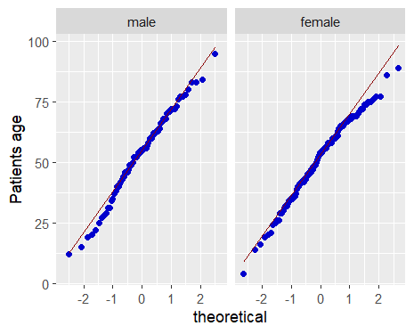

Figure 17. Showing a QQ-plot for patients’ age grouped by sex.

The qq-plot for patients' age grouped by gender is approximately normal for male and female. Normal data distribution for both gender.
6.3 QQ-plot for thickness grouped by gender.
Figure 18. Showing QQ-plot R code screenshot for patients’ age grouped by sex.
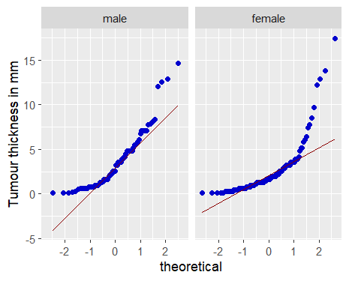

Figure 19. Showing QQ-plot for tumour thickness grouped by sex.

The qq-plot for tumour thickness grouped by gender is skewed to the right/ positively skewed for females and not normally distributed in both males and females.

7. DISCUSSION, CONCLUSION, AND RECOMMENDATIONS

7.1. Discussion and conclusion
After exploring the melanoma data set using R, we've gathered valuable insights into different aspects of the disease. Our exploration covered numerical and graphical summaries, detecting outliers, examining correlations, and analysing patterns in survival time, thickness, and age. However, these analyses collectively provide only a partial understanding, explaining a small portion of the variability in melanoma outcomes.
One noteworthy result comes from Welch's two-sample t-test on thickness between male and female groups. It indicates a statistically significant difference, suggesting that the observed gap in mean thickness between males and females is unlikely to be due to random chance. The confidence interval for the difference in means hints that, on average, melanoma thickness is higher in males than females. This finding could have clinical implications, influencing how we manage and treat melanoma, especially if thicker melanomas are associated with more severe outcomes or different treatment responses.
Our normality test for the variables by gender shows our data is normally distributed for the variables under study, the survival time, and tumour thickness for both gender is not normally distributed.
These insights can guide healthcare professionals in tailoring interventions, refining diagnostic practices, and enhancing overall patient care.
7.2. Recommendation
The weak correlation between the variables analysed, and the linear regression model only explained a small portion of variability between the variables. I recommend that other factors or variables should be considered to further explore the data set, for example exploring whether ulceration was present or absent can be considered, also I recommend other analysis, the relationship between tumour thickness and status of patients, ulcers and status of patients, ulcers, and survival time.
To deepen and broaden our understanding, future studies could focus on exploring identified trends, examining additional variables, and validating findings in larger data sets. This approach would contribute to a more comprehensive and widely applicable understanding of melanoma.
Furthermore, healthcare professionals should be aware of potential gender-related differences in melanoma thickness. It would be valuable to explore the clinical implications of this thickness difference. Are there correlations with prognosis, response to treatment, or other clinical outcomes? If applicable, public health campaigns could emphasize the importance of early detection and screening of melanoma, especially for individuals of a particular gender.
Finally, conducting further studies should be considered to validate and expand upon these findings. A larger sample size or additional factors (such as age, stage of melanoma, or other clinical variables) could be included in the analysis to provide a more comprehensive understanding.
REFERENCES
1. R Core Team version 4.3.2 2023 "Eye Holes" Copyright (C) 2023. The R Foundation for Statistical Computing Platform: x86_64-w64-mingw32/x64 (64-bit) https://www.R-project.org/

